Component 1

student id  77275260

Advanced Software

Table of Contents

Show help commands: 2

Action box testing: 2

Syntax testing: 3

Action Command testing: 3

Parameter testing: 4

Display shape testing: 5

Draw color command testing: 7

Fill on and Fill off color testing: 7

Move to testing: 8

Save code testing: 9

Load code testing: 10

Unit testing: 11

Github testing screen shot……………………………………………………………………...17

# Show help commands:

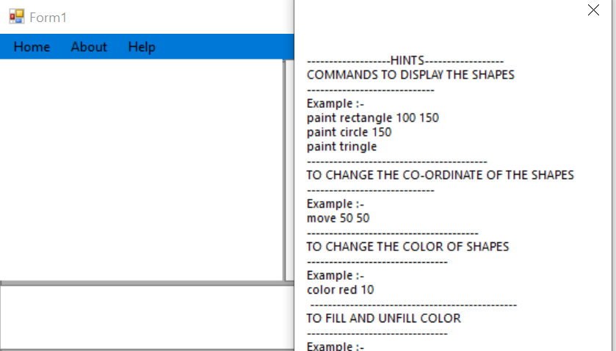

# Action box testing:

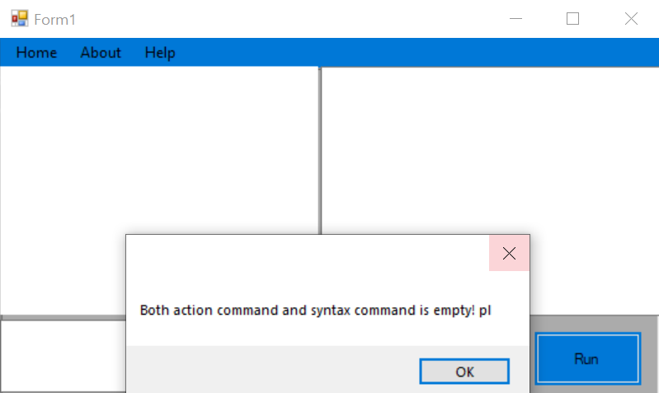

# Syntax testing:

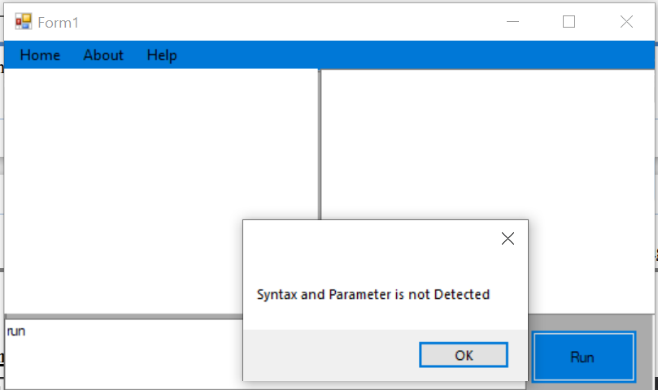

# Action Command testing:

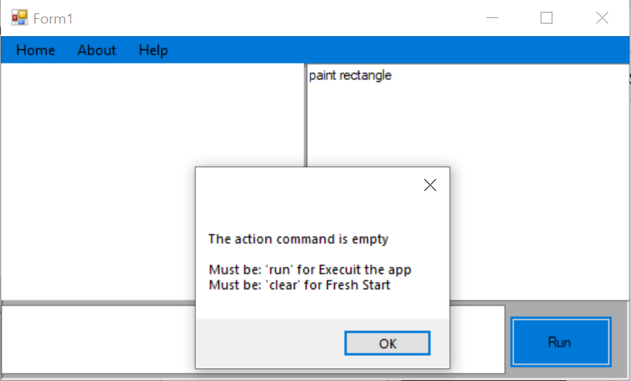

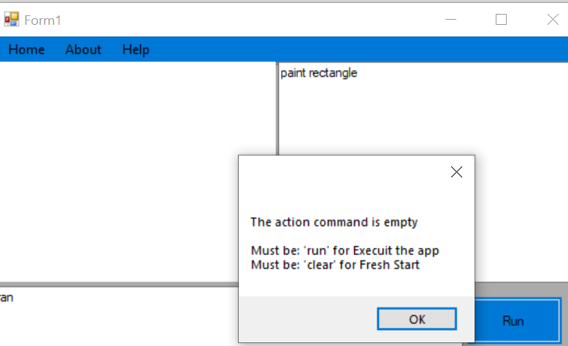

# Parameter testing:

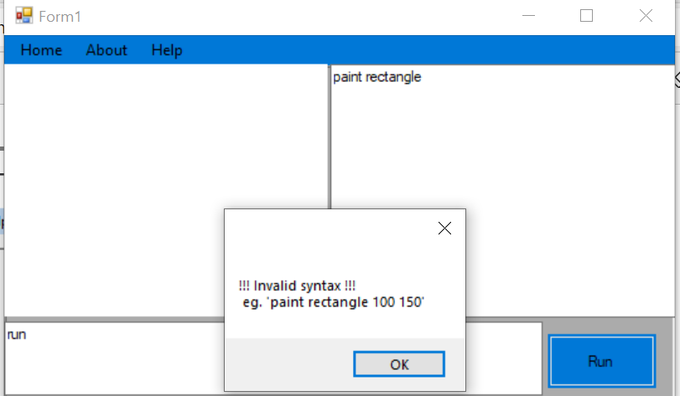

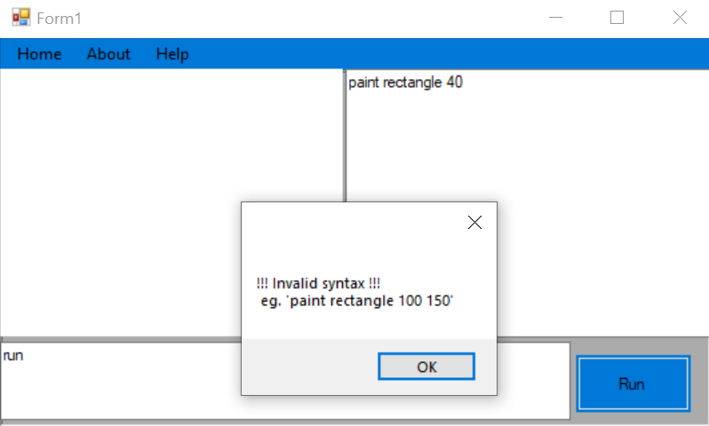

# Display shape testing:

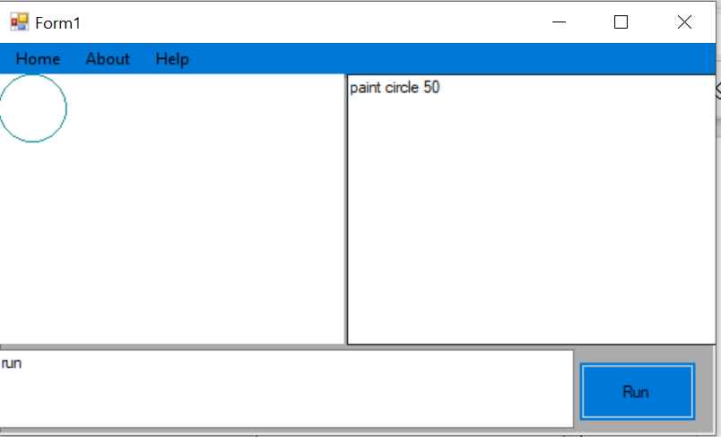

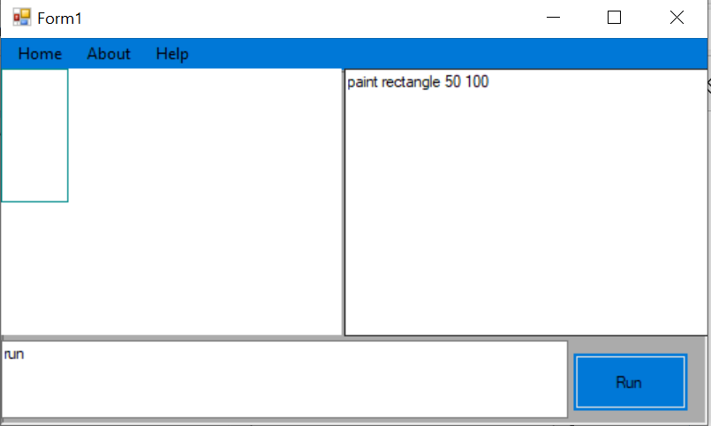

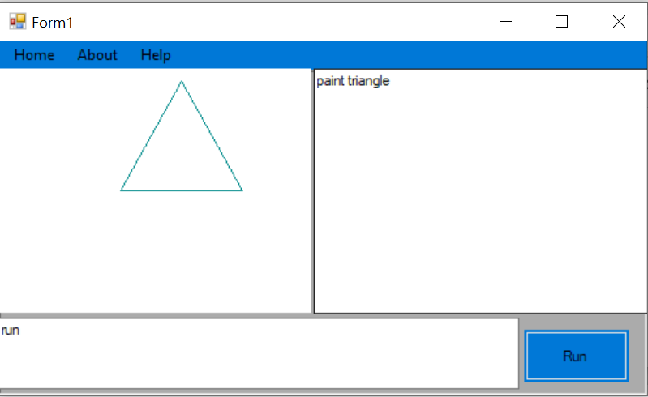

# Draw color command testing:

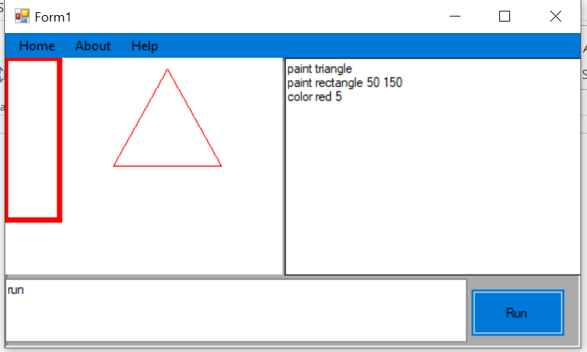

# Fill on and Fill off color testing:

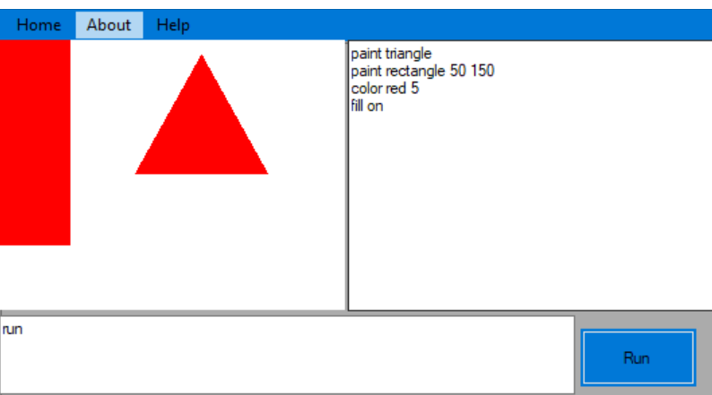

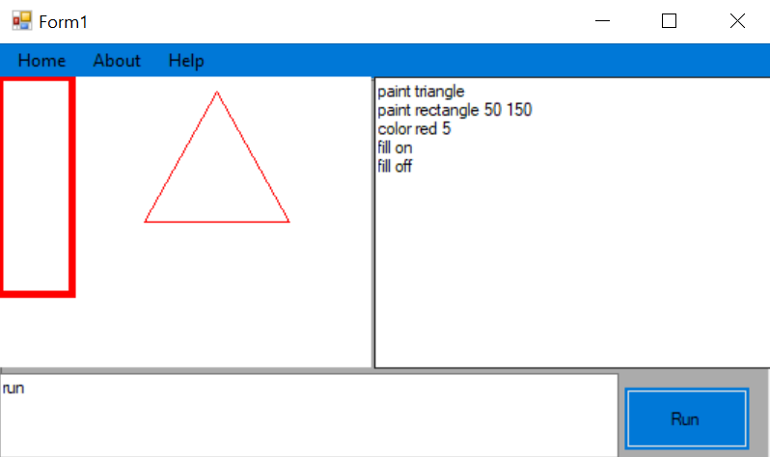

# Move to testing:

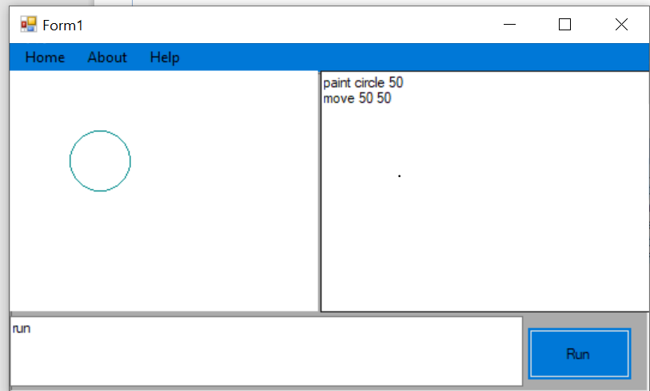

# Save code testing:

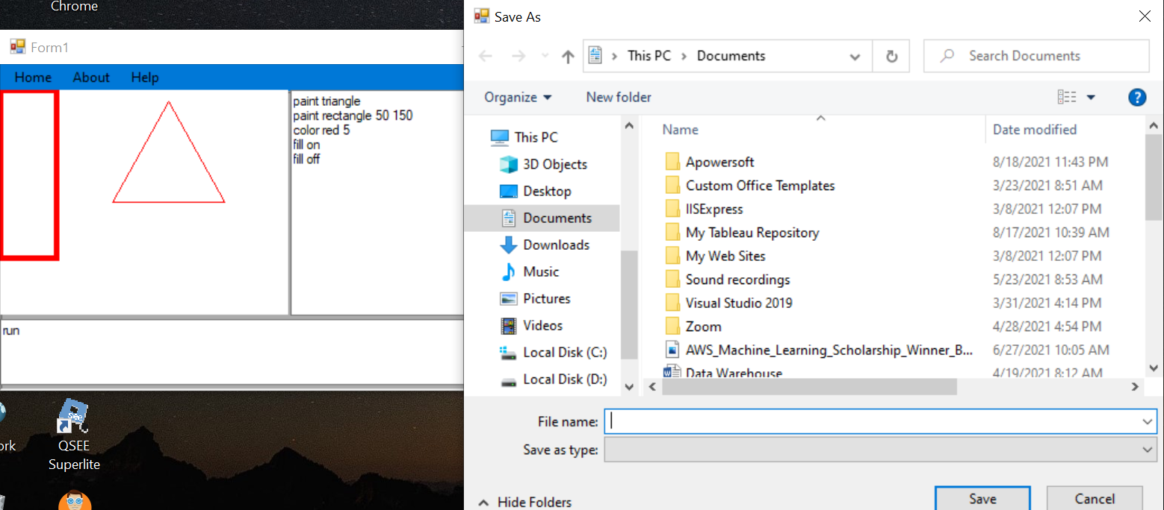

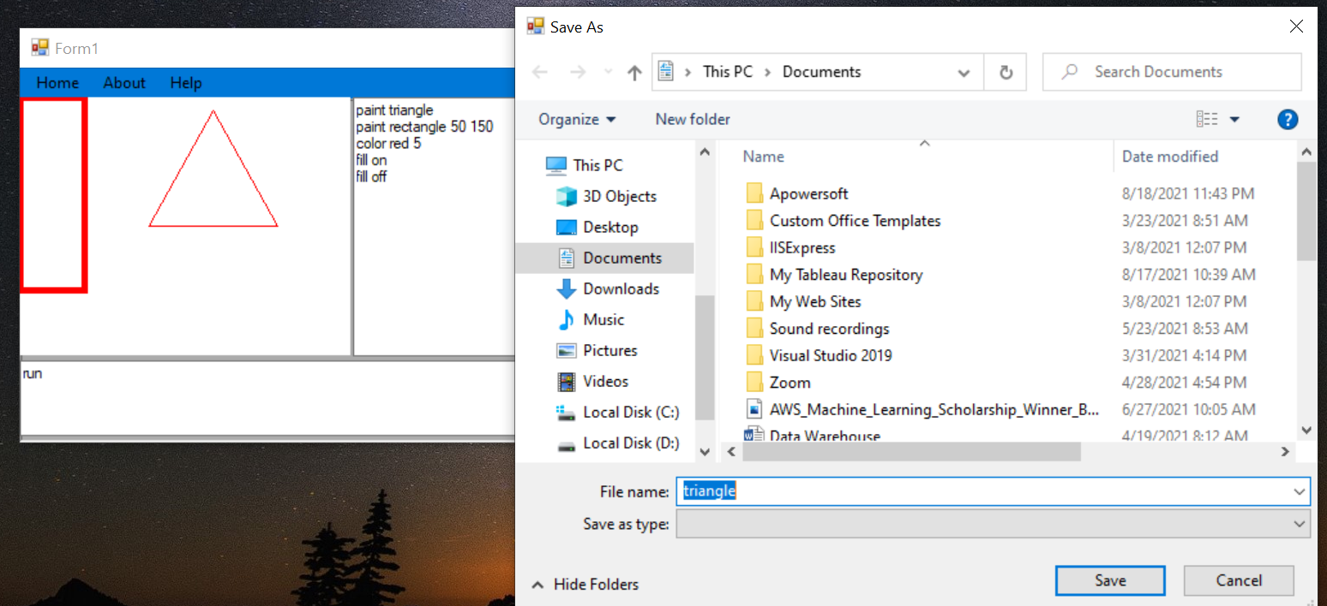

# Load code testing:

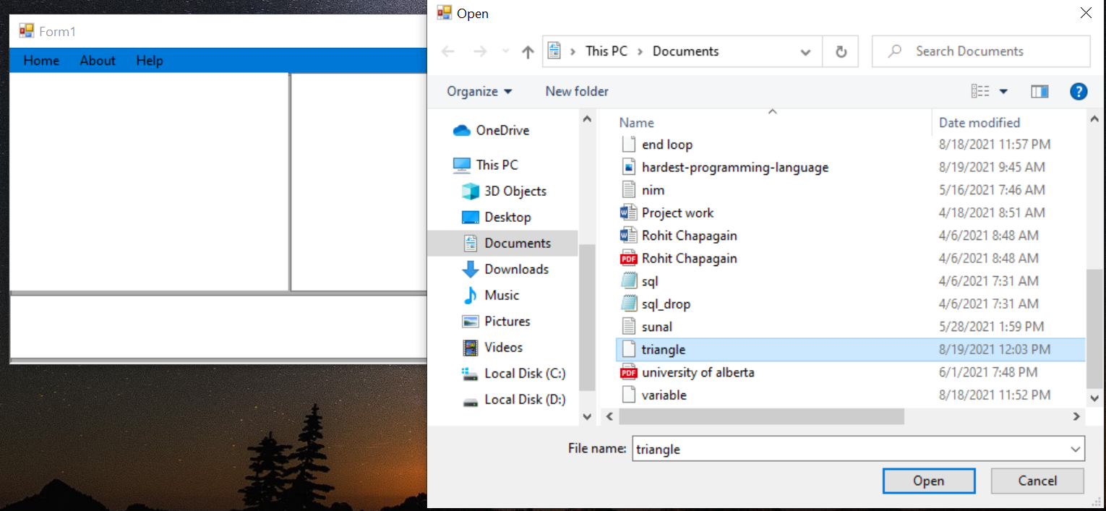

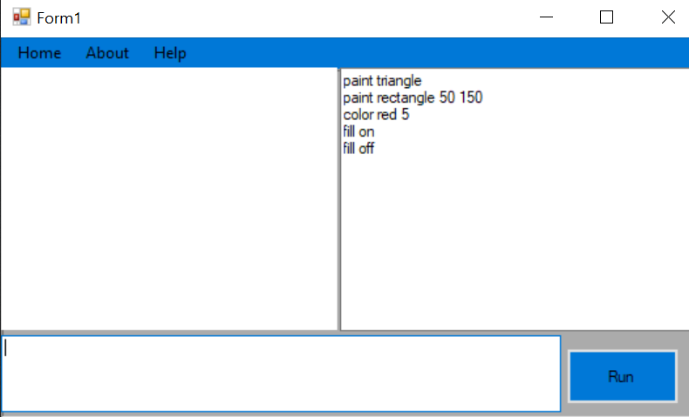

# Unit testing:

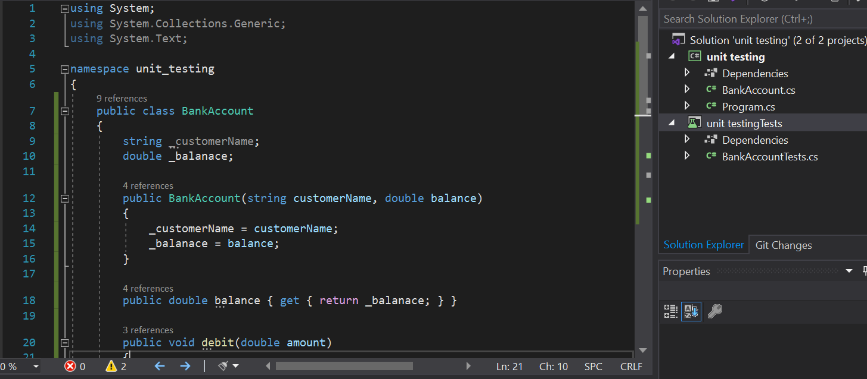

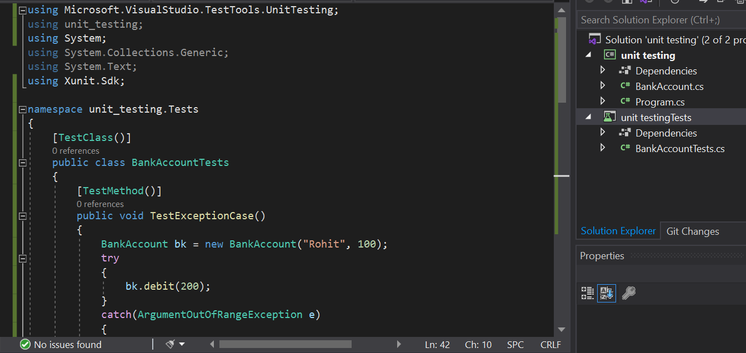

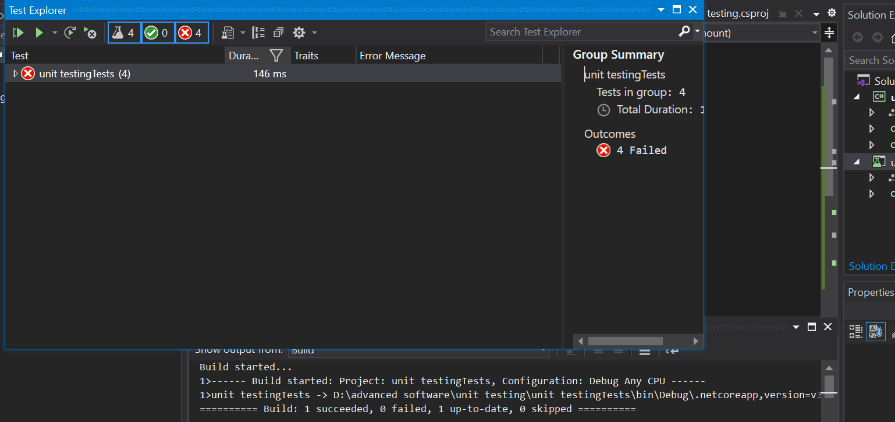

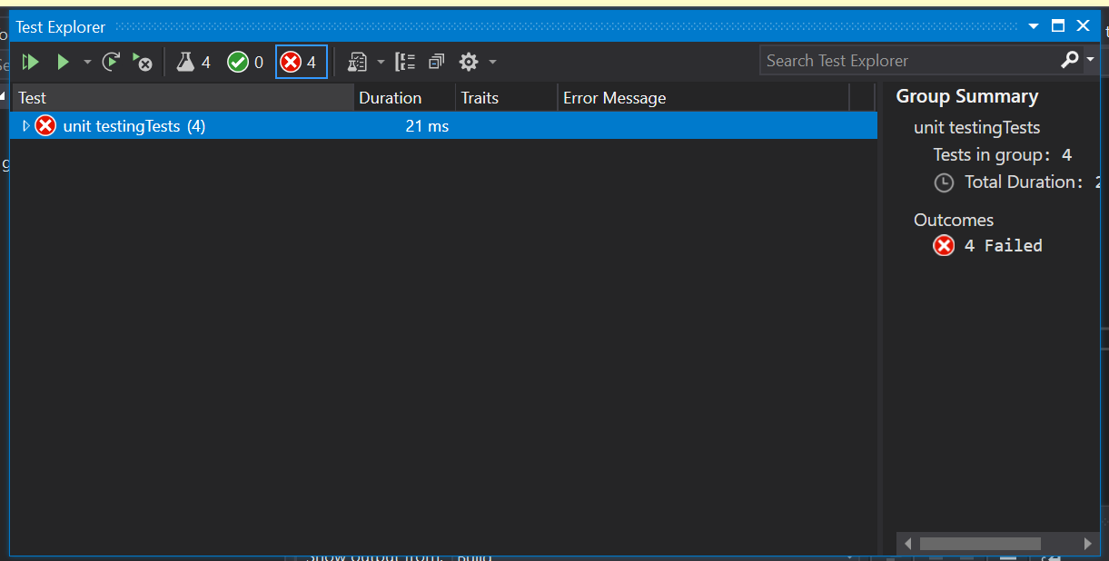

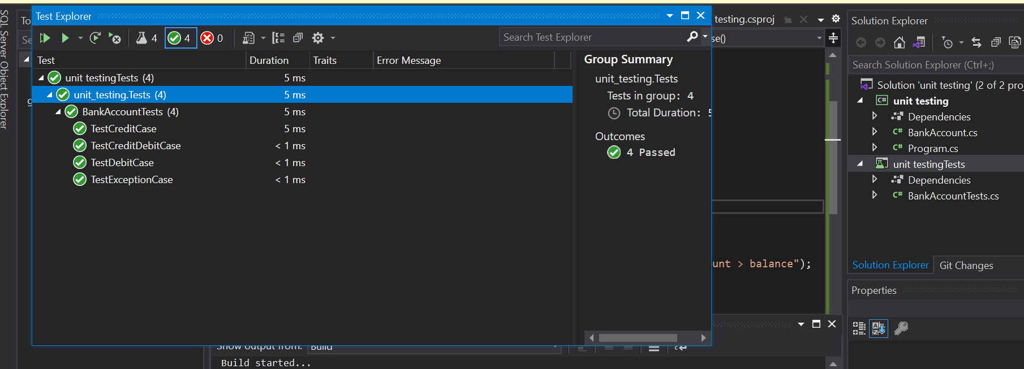

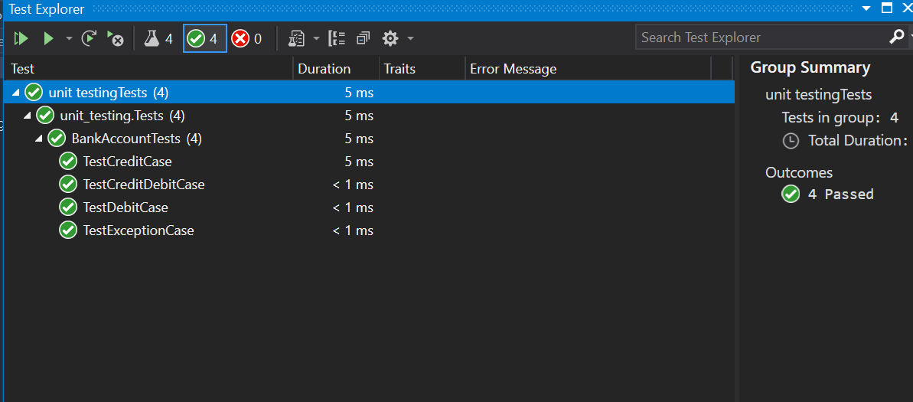

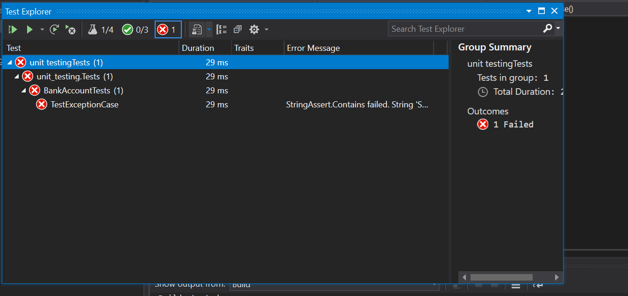

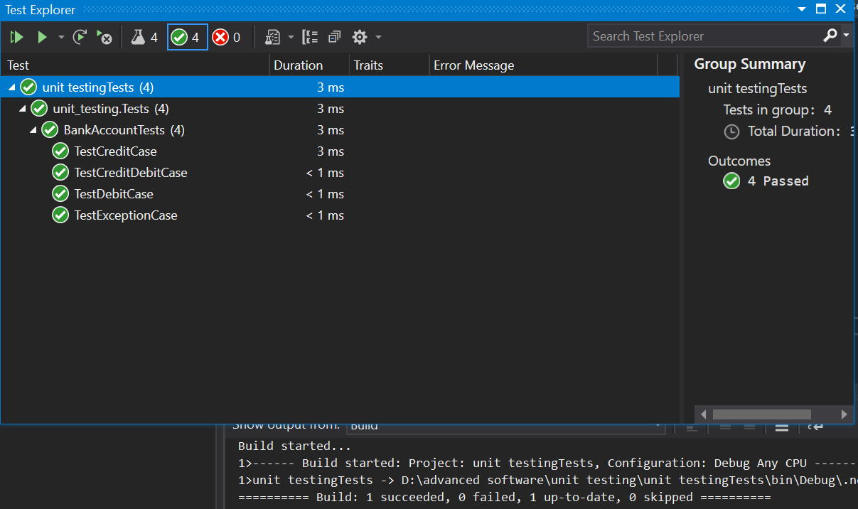

|  |  |  |  |  |  |  |  |  |  |  |  |  |  |
| --- | --- | --- | --- | --- | --- | --- | --- | --- | --- | --- | --- | --- | --- |
|  | | | | | | | | | | | | | |
| TEST CASE ID |  | | | | | | TEST CASE DESCRIPTION | | | | TEST TO DISPLAY CIRCLE, TRIANGLE AND RECTANGLE | | |
|  | | | | | | | | | | | | | |
| CREATED BY | | Rohit Chapagain | | REVIEWED BY |  | | | | | VERSION | | | 1.0 |
|  | | | | | | | | | | | | | |
| TESTERS`S NAME | | Rohit Chapagain | | TESTED DATE | 2021/8/12 | | | | | TEST RESULT | | | pass |
|  | | | | | | | | | | | | | |
| SN | PRE-REQUITIES | | | | |  | | | SN | TEST DATA | | | |
| 1 | Displaying Circle | | | | |  | | | 1 | Paint circle 50 | | | |
| 2 | Displaying Rectangle | | | | |  | | | 2 | Paint rectangle 50 100 | | | |
| 3 | Displaying Triangle | | | | |  | | | 3 | Paint Triangle | | | |
|  | | | | | | | | | | | | | |
| TEST SCENARIO | | | Validating and running circle rectangle and triangle successfully | | | | | | | | | | |
|  | | | | | | | | | | | | | |
| SN | STEP DETAILS | | | | EXCEPTED | | | ACTUAL RESULT | | | | PASS, FAIL OR NOT EXECUTED | |
| 1 | Open application | | | | Application should run | | | As excepted | | | | Pass | |
| 2 | Write code to draw circle in code box | | | | Command should entered | | | As excepted | | | | Pass | |
| 3 | Write code to draw rectangle in code box | | | | Command should entered | | | As excepted | | | | Pass | |
| 4 | Write code to draw triangle in code box | | | | Command should entered | | | As excepted | | | | Pass | |
| 5 | Enter run command at action box and click the run button | | | | It should execute application | | | As excepted | | | | Pass | |
|  | Enter clear command at action box and click the run button | | | | It should clear all the panel and text box | | | As excepted | | | | Pass | |
| 7 | Write code in text box and click at save button | | | | Written code should save in selected directory with name | | | As expected | | | | Pass | |
| 8 | Click at open button  To open save document | | | | Save code should open in text box | | | As excepted | | | | Pass | |
| 9 | Write a code to fill on and fill off | | | | Created shape should be fill with color when code is fill on fill off when code is fill off | | | As expected | | | | Pass | |
| 10 | Write a code to move the axis | | | | Axis should move to given number | | | As expected | | | | Pass | |
| 11 | Given invalid parameter for the shapes | | | | Should show error message with pop up dialog | | | As expected | | | | pass | |
|  | | | | | | | | | | | | | |

Github commit screen shot:

